Case 10-AM,S-Peru-Moche-Mushroom Shaman-100-700 CE

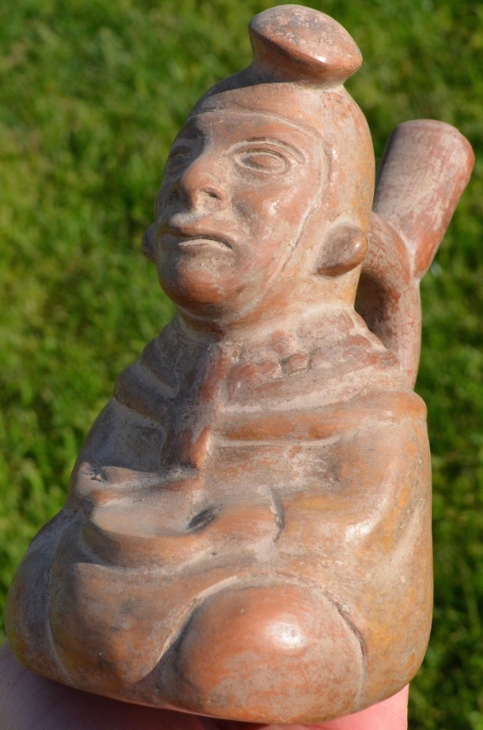

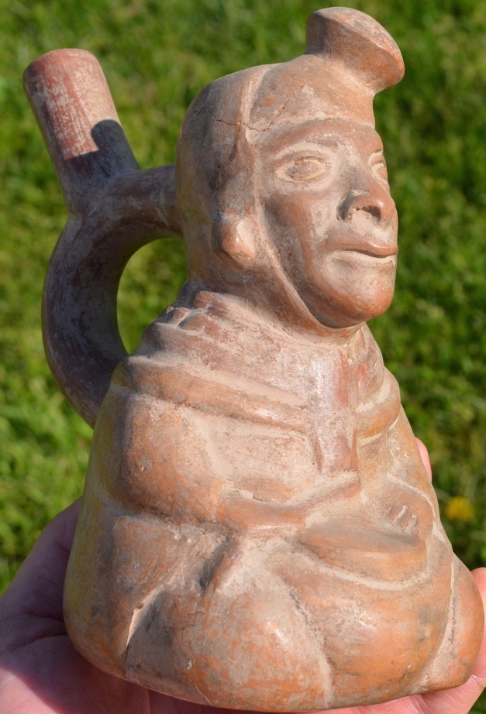 

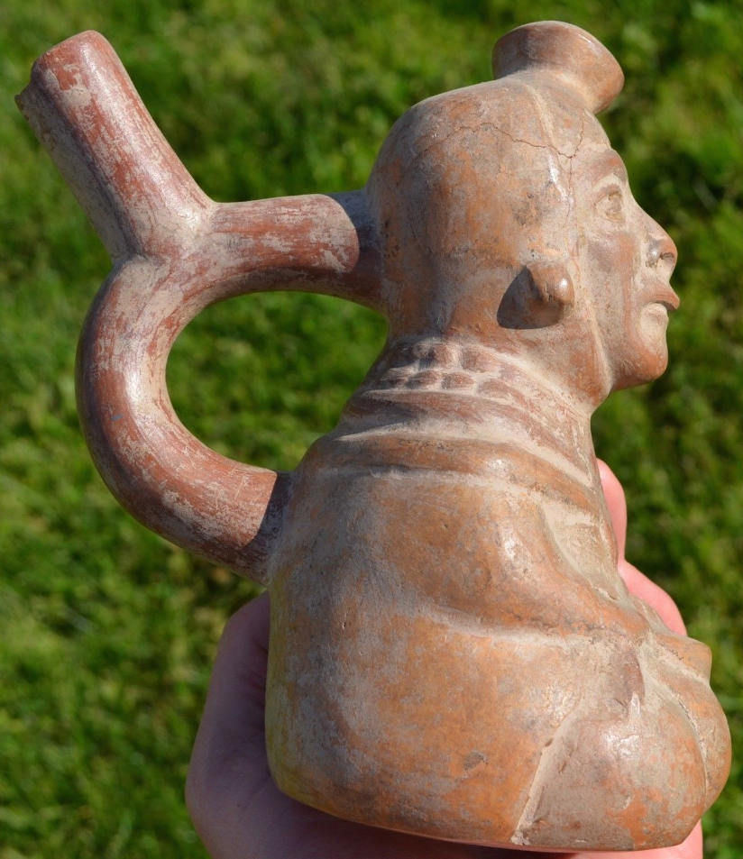 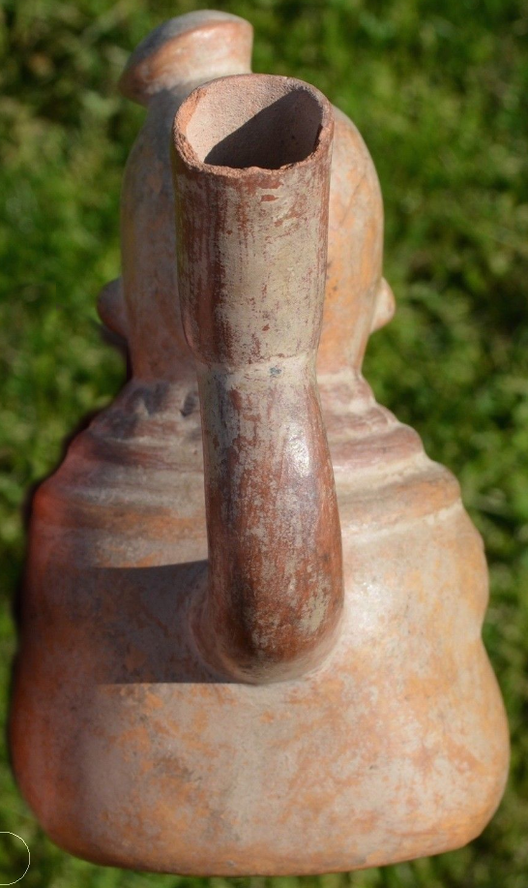 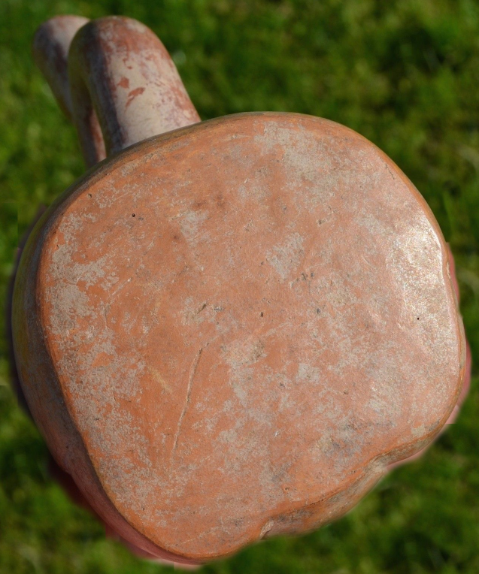

Figs. 1-5. Peru-Moche-Mushroom Shaman-100-700 CE

**Case no.:**

**Accession Number:**

**Formal Label:** Peru-Moche-Mushroom Shaman-100-700 CE

**Display Description:**

The Moche produced ceramics with unmistakable representations of mushrooms. In the current example the shaman has a red mushroom protruding from his head. He is seated with his hands holding a dish into which mushrooms were to be placed.

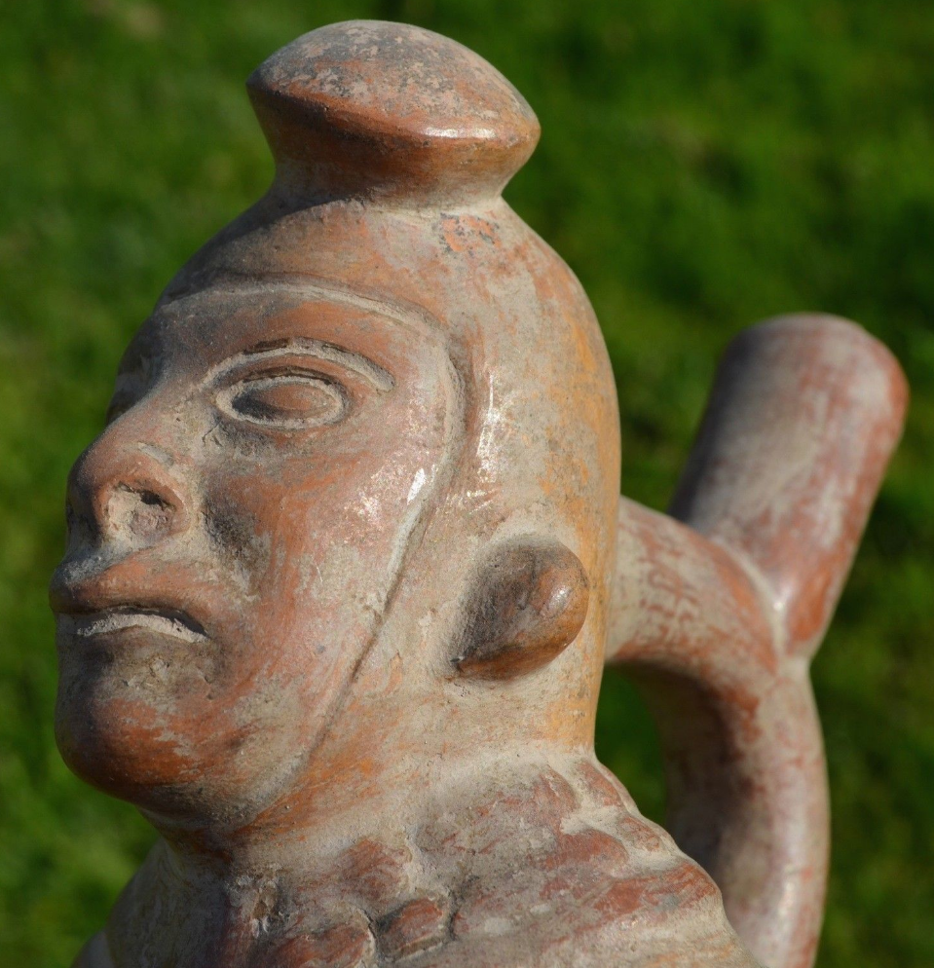 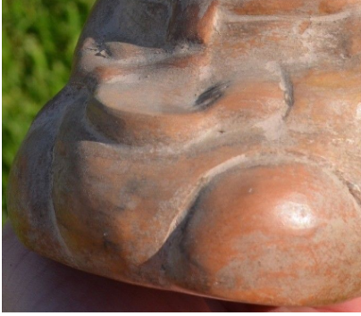

Figs 6-7. Peru-Moche-Mushroom Shaman showing the mushroom on his cap and the bowl for placing them in that he holds.

In this ceramic we have clear evidence that *Psilocybe mexicana* was used by the Moche (Borhegyi 2010). This species is identified by its conical cap and reddish brown color. The species also includes P. cubencis, P. yungensis and P. zapotecorum, which are also featured on Moche ceramics (Pavlich M.R. 1976, Guzman et al. 2000, Guzmán G. 2009). These Moche phase IV ceramics may be used as a stepping stone (Castillo et al. 2007) to finding a direct link between these ceramics through the botanic identification of fungal spores in archaeological sites.

The Psilocybe species was used as an entheogen in Mesoamerica, and it is documented in the Quiche Mayan text, the *Popol Vuh*. The *Popol Vuh* is a creation narrative written by the  [K'iche' (**Quiché**) people](https://en.wikipedia.org/wiki/K%27iche%27_people) before the [Spanish burned most of the texts of the indigenous Guatemala](https://en.wikipedia.org/wiki/Spanish_conquest_of_Guatemala)ns because these texts did notagree with the Judaeo-Christian Bible. The *Popol Vuh* was preserved through oral tradition[[3]](https://en.wikipedia.org/wiki/Popol_Vuh#cite_note-3) until approximately 1550 when it was written down.[[4]](https://en.wikipedia.org/wiki/Popol_Vuh#cite_note-4) The survival of the *Popol Vuh* is credited to the 18th century [Dominican friar](https://en.wikipedia.org/wiki/Dominican_friar) [Francisco Ximénez](https://en.wikipedia.org/wiki/Francisco_Xim%C3%A9nez) who made a copy of the original text in Spanish[[5]](https://en.wikipedia.org/wiki/Popol_Vuh#cite_note-5) The name "Popol Vuh" translates as "Book of the Community", "Book of Counsel", or more literally as "Book of the People".[[6]](https://en.wikipedia.org/wiki/Popol_Vuh#cite_note-6)[[7]](https://en.wikipedia.org/wiki/Popol_Vuh#cite_note-7) The Popol Vuh includes the Mayan [creation myth](https://en.wikipedia.org/wiki/Creation_myth), beginning with the exploits of the [Hero Twins](https://en.wikipedia.org/wiki/Maya_Hero_Twins) Hunahpú and Xbalanqué.[[8]](https://en.wikipedia.org/wiki/Popol_Vuh#cite_note-8) As with similar texts (*[Chilam Balam](https://en.wikipedia.org/wiki/Chilam_Balam" \o "Chilam Balam)*, being one example), a great deal of the *Popol Vuh's* significance lies in the scarcity of early accounts dealing with [Mesoamerican mythologies](https://en.wikipedia.org/wiki/Mesoamerican_mythology) due to the burning of documents by the Spanish [Conquistadors](https://en.wikipedia.org/wiki/Conquistador).[[9]](https://en.wikipedia.org/wiki/Popol_Vuh#cite_note-9)

R. Gordon Wasson brought these rituals to the attention of the world (Wasson R.G. 1957) documenting the mushroom ceremonies of the local healers such as Eva Mendez (Maria Sabina). Today, Mexico is known as a center of over 50 Psilocybe species Guzman et al (2000).

Psilocybin is the major of two hallucinogenic components of Teonanacatl (flesh of the gods), the sacred mushroom of Mexico, the other component being psilocin. (From Merck Index, 13th ed). Psilocybin or DMT: [dimethyltryptamine](https://en.wikipedia.org/wiki/Dimethyltryptamine) is a naturally occurring psychedelic prodrug compound produced by more than 200 species of mushrooms, collectively known as psilocybin mushrooms. Psilocybin evolved in mushrooms from its ancestor, muscarine, some 20 million years ago.[[4]](https://en.wikipedia.org/wiki/Psilocybin#cite_note-plos-5) Psilocybin is isolated from various genera of fungi including the genus Psilocybe, with hallucinogenic, anxiolytic, and psychoactive activities. In vivo, psilocybin is rapidly dephosphorylated into the active compound [psilocin](https://pubchem.ncbi.nlm.nih.gov/compound/psilocin), which activates [serotonin](https://pubchem.ncbi.nlm.nih.gov/compound/serotonin) 2A (5-HT2A) receptors in the central nervous system (CNS), mimicking the effects of [serotonin](https://pubchem.ncbi.nlm.nih.gov/compound/serotonin).

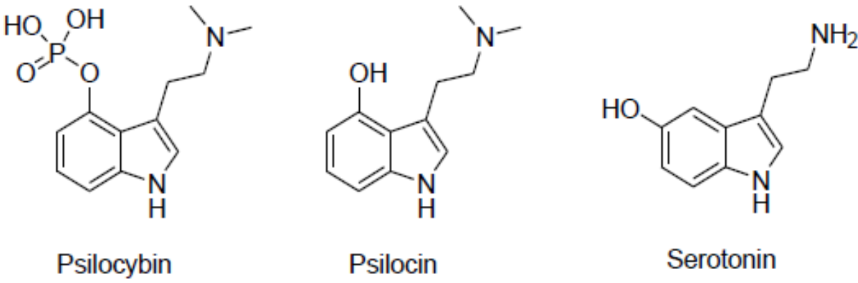

Fig. 9. Chemical structures of psilocybin, psilocin and serotonin.

The most potent are members of the genus [Psilocybe](https://en.wikipedia.org/wiki/Psilocybe" \o "Psilocybe), such as [P. azurescens](https://en.wikipedia.org/wiki/Psilocybe_azurescens), [P. semilanceata](https://en.wikipedia.org/wiki/Psilocybe_semilanceata), and [P. cyanescens](https://en.wikipedia.org/wiki/Psilocybe_cyanescens), but psilocybin has also been isolated from about a dozen other species such as P. Mexicana.

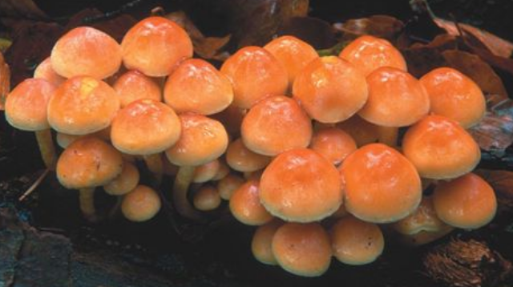

Fig. 10. *P. Mexicana* after <http://slideplayer.com/slide/6845454/23/images>.

As a prodrug, psilocybin is quickly converted by the body to psilocin, which has mind-altering effects similar, in some aspects, to those of LSD, mescaline, and DMT. In general, the effects include euphoria, visual and mental hallucinations, changes in perception, a distorted sense of time, and spiritual experiences, and can include possible adverse reactions such as nausea and panic attacks.

**LC Classification: F3430.1.**

**Date or Time Horizon:** 400 BCE-600 CE

**Geographical Area:** North coastal Peru

**Map, GPS coordinates: -6.80139 -79.60202; 6º48'5" S 79º36'7.28" W.**

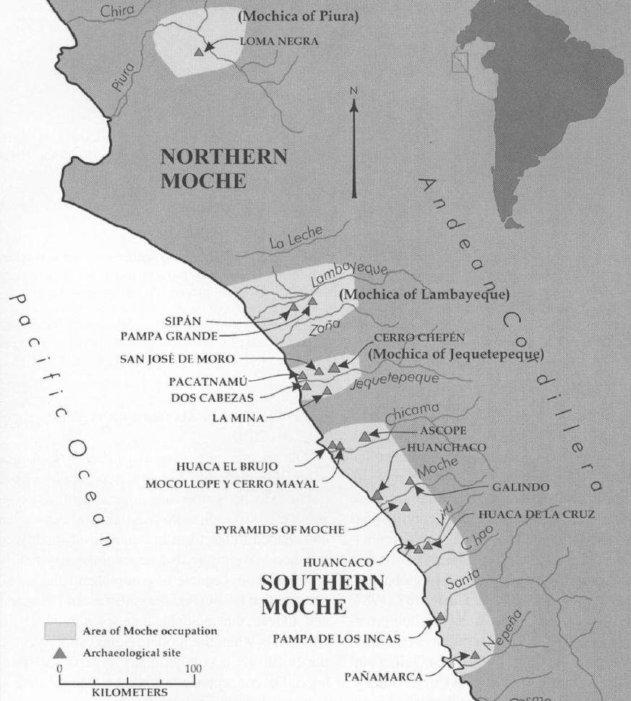

Fig. 11. Map of Moche regions as currently conceived and significant Moche sites. Map courtesy Moro Archaeological program.

**Cultural Affiliation:** Moche, Mochica

**Media:** clay; polychrome colors: red, cream, black, skin color

**Dimensions:** H mm; in

**Weight: gm; oz**

**Condition: original**

**Provenance:** unknown

**Discussion: (Attributed to Wiki)**

In Mesoamerica, the mushrooms had long been consumed in spiritual and divinatory ceremonies before Spanish chroniclers first documented their use in the 16th century. Archaeological artifacts from Mexico, as well as the so-called Mayan "mushroom stones" of Guatemala have also been interpreted by some scholars as evidence for ritual and ceremonial usage of psychoactive mushrooms in the Mayan and Aztec cultures of Mesoamerica ( Stamets P. 1996: 11)

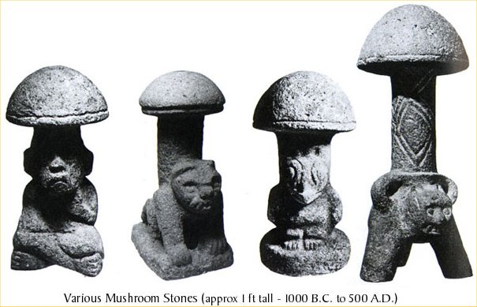

Fig. 12. Mushroom stones of the Quiche Maya from Guatemala after https://upload.wikimedia.org/wikipedia/commons/a/a4/Psilocybe_Mushrooms_statues.jpg

In Nahuatl, the language of the Aztecs, the mushrooms were called *teonanácatl*, or "God's flesh". Following the arrival of Spanish explorers to the New World in the 16th century, chroniclers reported the use of mushrooms by the natives for ceremonial and religious purposes. According to the Dominican friar Diego Durán in *The History of the Indies of New Spain* (1581), mushrooms were eaten in festivities conducted on the occasion of the accession to the throne of Aztec emperor Moctezuma II in 1502. The Franciscan Bernardino de Sahagún witnessed mushroom use in his *Florentine Codex* (published 1545–1590),and described how merchants upon returning from a successful business trip would consume mushrooms to evoke revelatory visions (Marley 2010: 164). After the defeat of the Aztecs, the Spanish forbade traditional religious practices and rituals that they considered "pagan idolatry", including ceremonial mushroom use. For the next four centuries, the First Peoples of Mesoamerica secreted their use of entheogens from the Spanish authorities (Marley 2010: 165). In 1957, American banker and ethnomycologist R. Gordon Wasson and his wife Valentina Pavlovna Guercken (1901–1958), a pediatrician, published *Mushrooms, Russia and History* in 1957 that described their experiences ingesting psilocybin-containing mushrooms during a traditional ceremony under the direction of Maria Sabina, a curanduro or healer, in Mexico, which introduced the substance to popular culture. In 1959, the Swiss chemist Albert Hofmann isolated the active principle psilocybin from the mushroom *Psilocybe mexicana*. Hofmann’s employer Sandoz marketed and sold pure psilocybin to physicians and clinicians worldwide for use in psychedelic psychotherapy

**References:**

Alva, Waltsr and Chrisopher R. Donnan. 1993. *Royal Tombs of Sipan*, Fowler Museum of Cultural History, Los Angeles: UCLA.

[Anon.](https://en.wikipedia.org/wiki/Moche_culture#cite_ref-4)  [The Salinar Culture](http://www.tampere.fi/ekstrat/taidemuseo/arkisto/peru/800/salinar_en.htm) Tampere Museum

Bawden, G. 2004. "The Art of Moche Politics". In Silverman, H. **Andean Archaeology**. Oxford: Blackwell Publishers.

Beck, Roger B.; Black, Linda; Krieger, Larry S.; Naylor, Phillip C.; Shabaka, Dahia Ibo (1999). *World History: Patterns of Interaction.* Evanston, IL: McDougal Littell. [ISBN](https://en.wikipedia.org/wiki/International_Standard_Book_Number) [0-395-87274-X](https://en.wikipedia.org/wiki/Special:BookSources/0-395-87274-X).

Benson, Elizabeth P. 1972 *The Mochica, a culture of Per*u. New Yorlr, Washington, D.C.: Praeger Publishers.

Benson, Elizabeth P. 1974. *A Man and a Feline in Mochica Art*. Washington, D.C.: Dumbarton Oaks, Trustees for Harvard University.

Butters, Castillo and Luis Jaime. ["Moche Politics in the Jequetepeque Valley"](http://sanjosedemoro.pucp.edu.pe/descargas/articulos/MocheJequetepeque.pdf) (PDF). Retrieved 2012-11-23

Butters, Castillo.2007. "The Moche of Northern Perú". In Silverman, H.; Isbell, W. [*Handbook of South American Archaeology*](http://sanjosedemoro.pucp.edu.pe/descargas/articulos/TheMochePeru.pdf) (PDF). Blackwell Press.

Cardenas, Maritza (ed.). ["Huacas del Sol y de la Luna – Capital de la Cultura-Mochica"](http://sobre-peru.com/2009/09/11/cultura-mochica-pre-inca-en-el-norte-peruano/) (in Spanish). Retrieved 2012-03-29.

Castillo Butters L.J. Uceda Castillo S. 2007. The Moche of northern Peru. In *Handbook of South American*

*Archaeology*, edited by Helaine Silverman and William Isbell. London: Blackwell Press.

Chapdelaine, Claude; Kennedy, Greg; Uceda Castillo, Santiago (1995). ["Neutron activation analysis and local production of ritual ceramics at the Moche site, Peru"](http://www.ifeanet.org/publicaciones/boletines/24(2)/183.pdf) (PDF). *Bulletin de l'Institut Francais d'Etudes Andines* 24 (2): 183–212.

[Keys, David](https://en.wikipedia.org/wiki/David_Keys_(author)). 2000. "The Mud of Hades". *Catastrophe: an Investigation into the Origins of the Modern World* (1st [American] ed.). New York: Ballantine Books. [ISBN](https://en.wikipedia.org/wiki/International_Standard_Book_Number) [0345444361](https://en.wikipedia.org/wiki/Special:BookSources/0345444361).

Davidson, Nick. 2 March 2005. ["Lost society tore itself apart"](http://news.bbc.co.uk/2/hi/science/nature/4311153.stm). BBC Horizon. Retrieved 2005-05-04.

Lovett, Richard A. August 18, 2006. ["Photo in the News: Looted Peru Headdress Recovered in London"](http://news.nationalgeographic.com/news/2006/08/060818-peru-headdress.html). *National Geographic News*. Retrieved 2010-12-18.

Marley G. 2010. "Psilocybin: gateway to the soul or just a good high?". Chanterelle Dreams, Amanita Nightmares: The Love, Lore, and Mystique of Mushrooms. White River Junction, Vermont: Chelsea Green Publishing, pp. 163–84.

McClellan III, James E.; Harold Dorn. 2006. [*Science and Technology in World History: An Introductio*n](https://books.google.com/books?id=aJgp94zNwNQC). JHU Press; 14 April 2006.  p. 40.

Norris, Scott (May 16, 2006). ["Mummy of Tattooed Woman Discovered in Peru Pyramid"](http://news.nationalgeographic.com/news/2006/05/mummy-peru.html). *National Geographic News.*

Popson, C. 2012. ["Moche Culture"](http://www.about-peru-history.com/moche-culture.html). *About Peru History*. Retrieved 2012-05-22.

[Scher](https://smarthistory.org/author/dr-sarahh-scher/), Dr. Sarahh and [Steven Zucker](https://smarthistory.org/author/szucker/). 2015. ["Pair of Earflares, Winged Messengers (Moche Culture, Peru)"](http://smarthistory.org/pair-of-earflares-winged-messengers/). *[Smarthistory](https://en.wikipedia.org/wiki/Smarthistory" \o "Smarthistory).*

Sharon, Douglas. 2000. *Shamanism and the sacred cactus: ethnoarchaeolgical evidence for the San Pedro use in northern Peru.* San Diego: San Diego Museum of Man.

Stamets P. 1996. Psilocybin Mushrooms of the World: An Identification Guide. Berkeley, California: Ten Speed Press.

Sutherland, Scott. August 29, 2013. ["Unearthed Peruvian tomb confirms that women ruled over brutal ancient culture"](https://news.yahoo.com/blogs/geekquinox/unearthed-peruvian-tomb-confirms-women-ruled-over-brutal-160013738.html). *Yahoo! News*. Retrieved 2013-08-29.

Vecchio, Rick. September 15, 2006. ["Looted gold headdress returned to Peru"](http://archive.peruthisweek.com/news-2448-looted-gold-headdress-returned-to-peru/). *Peru This Week.* AP.

Williams. Ann R. 2013. “[Tomb of a Powerful Moche Priestess-Queen Found in Peru.](http://news.nationalgeographic.com/news/http-/news/news/2013/08/130808-moche-priestess-queen-tomb-discovery-peru-archaeology-science/)”  nationalgeographic.com

Weismantel, M. 2004. ["Moche sex pots: Reproduction and temporality in ancient South America"](http://www.latinamericanstudies.org/moche/moche-sex-pots.pdf) (PDF). *American Anthropologist*. 106 (3): 495–496.

[Zucker, Steven, and Dr. Sarahh Scher, 2016. Moche Portrait Head Bottle"](http://smarthistory.org/moche-portrait-bottle/). *[Smarthistory](https://en.wikipedia.org/wiki/Smarthistory" \o "Smarthistory).*